Following ContentTypes
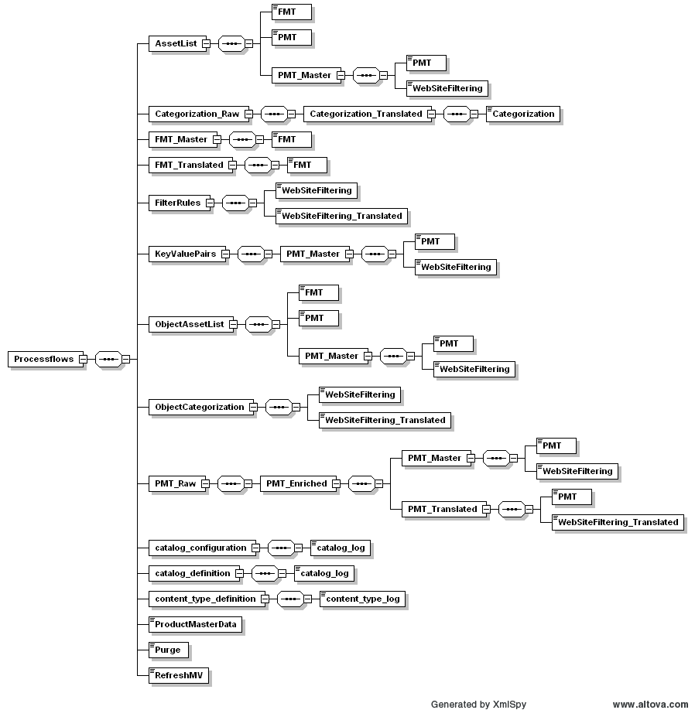
bron: OCTL_Relations
Following ContentTypes
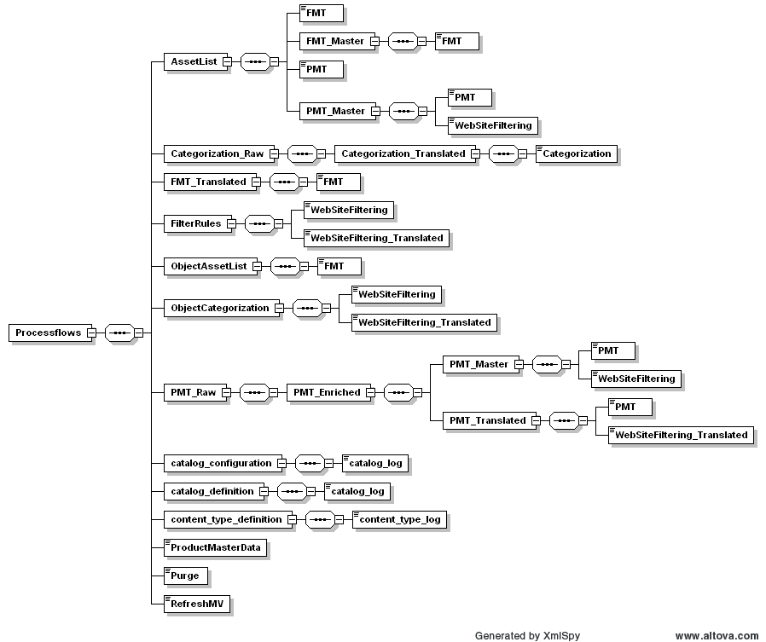
bron: CTL_Relations
Preceding ContentTypes
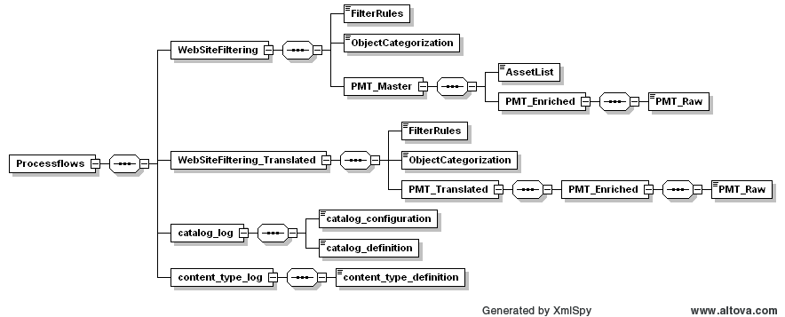
bron: CTL_Relations

